# Exercise 3 - In-Lab Task 1

## First Order Systems

### First Order Mechanical System

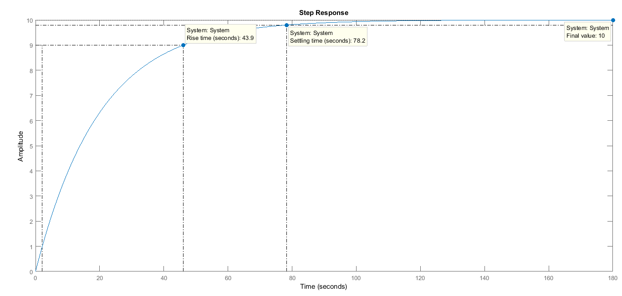

Step Response

### First Order Electrical System

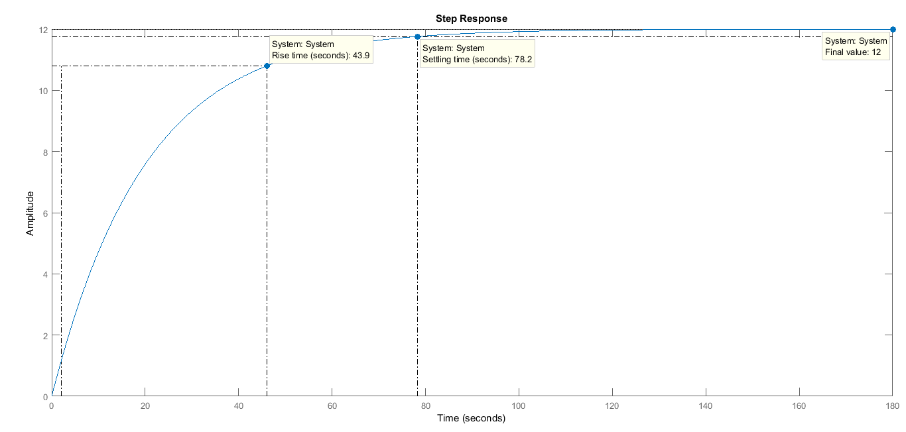

Step Response

## Second Order Systems

### Second Order Mechanical System

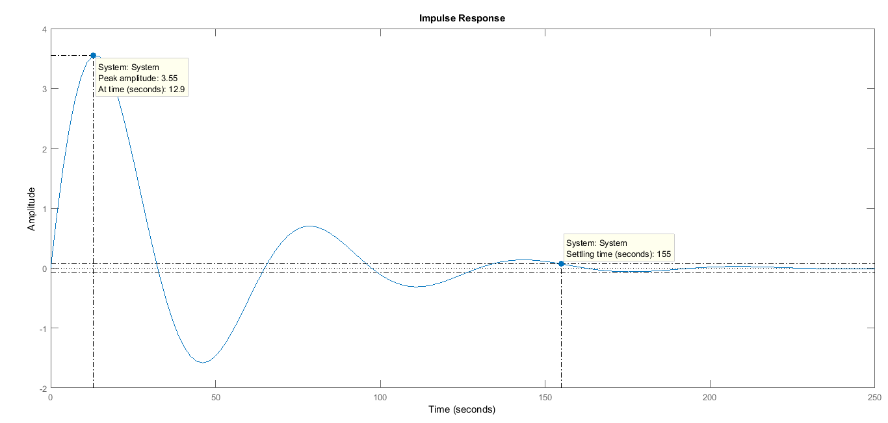

Impulse Response

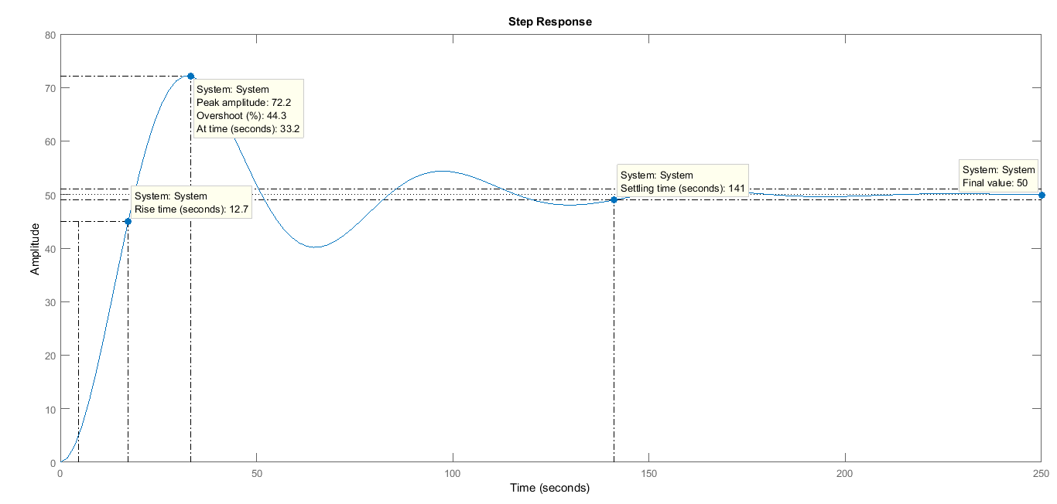

Step Response

### Second Order Electrical System

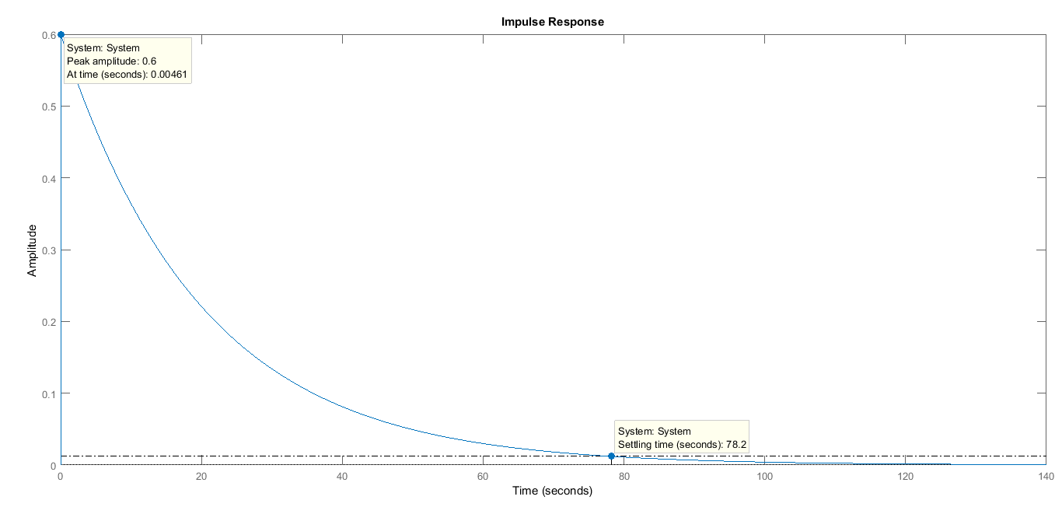

Impulse Response

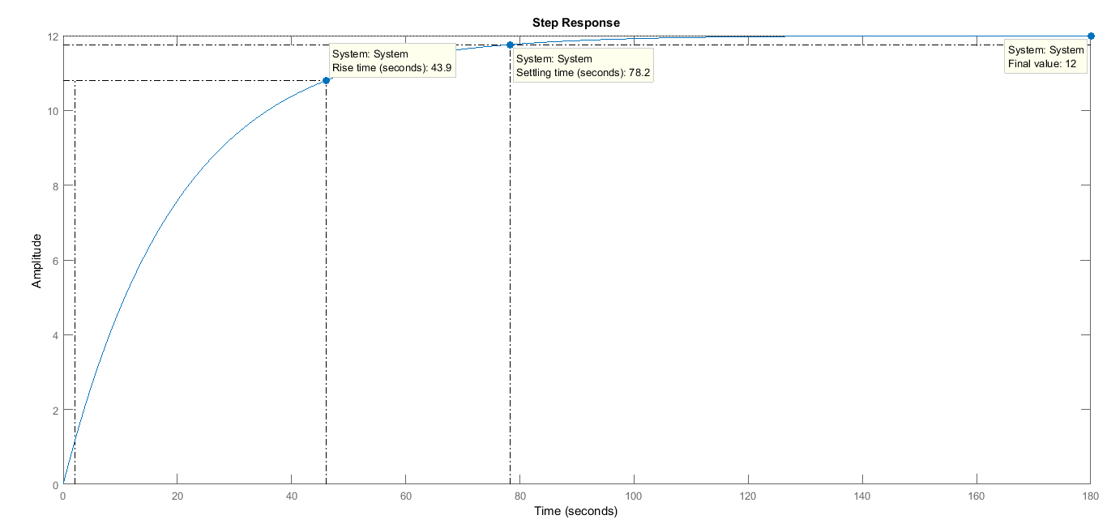

Step Response

# Exercise 3 - In-Lab Task 2

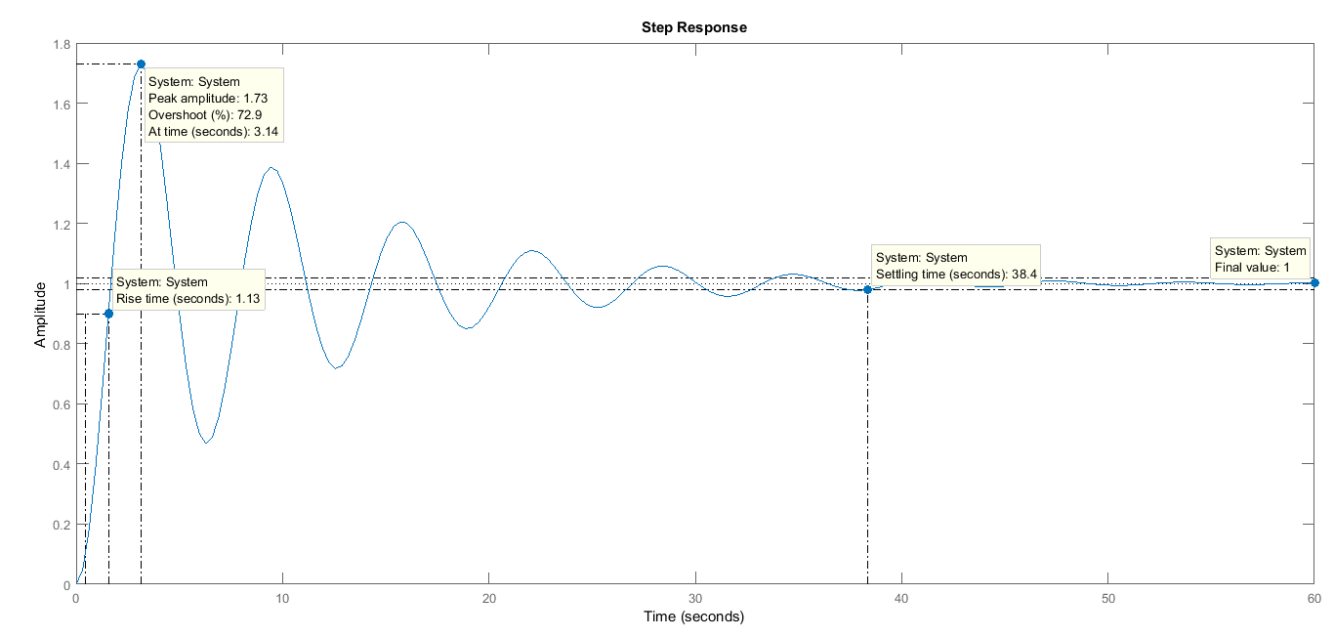

Damping Ratio $ζ=0.1$

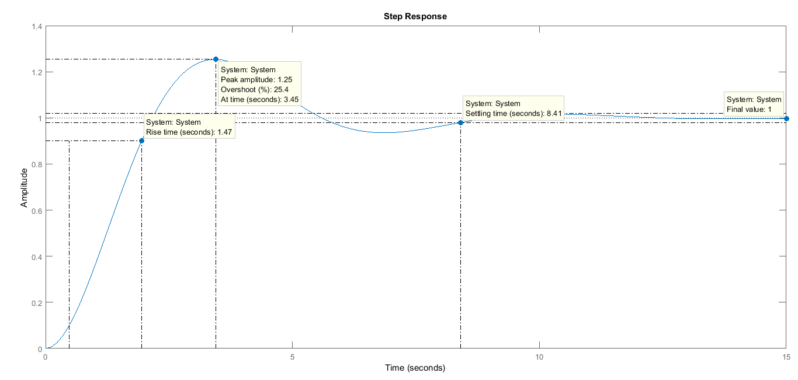

Damping Ratio $ζ=0.4$

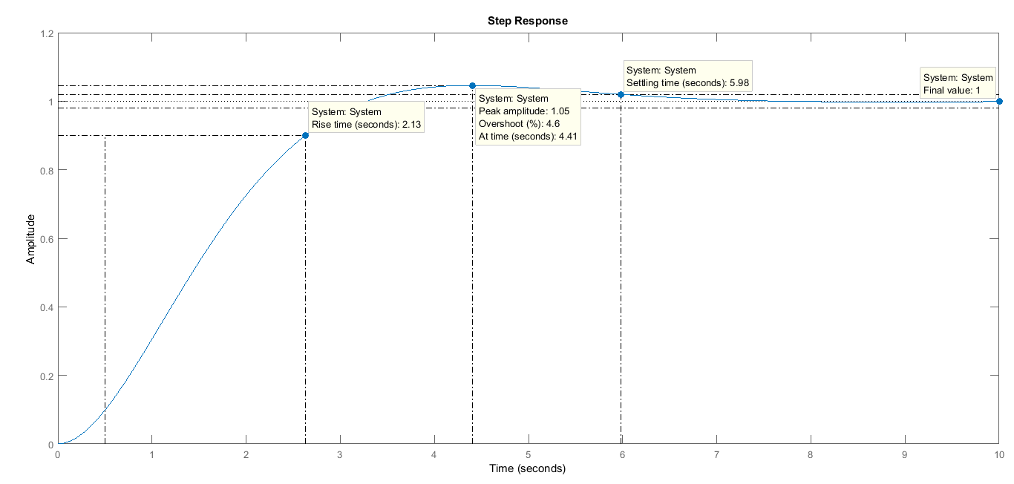

Damping Ratio $ζ=0.7$

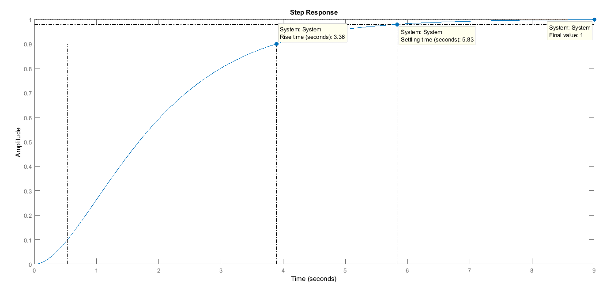

Damping Ratio $ζ=1.0$

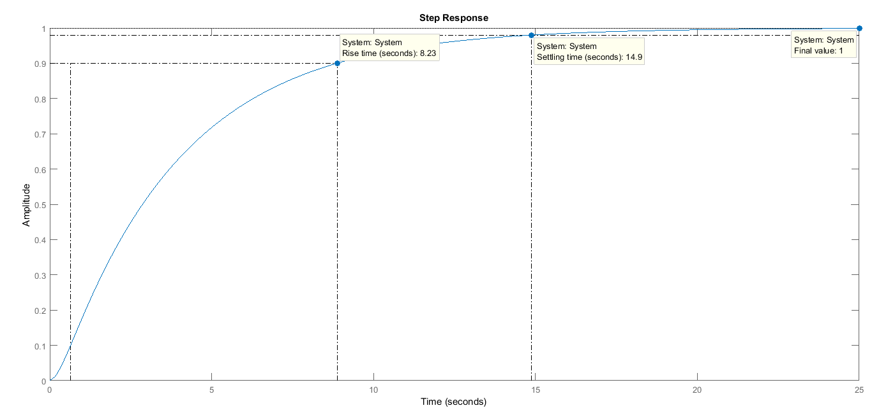

Damping Ratio $ζ=2.0$